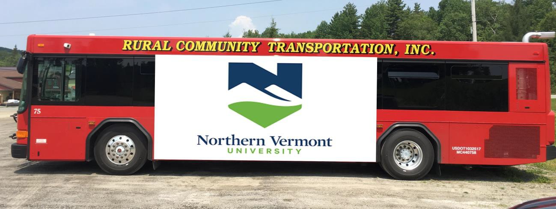

Sponsorship advertising on RCT’s US 2 Commuter Bus Route
The US2 Commuter Bus Route is serviced by RCT’s newest and largest heavy duty bus, making two roundtrips daily (Monday – Friday) between Downtown St. Johnsbury and Downtown Montpelier.

Advertising Space Rates (3-month minimum commitment)
Premium Advertising Space: Middle of bus, one side, can cover windows
3 months = $600 per month 6 months = $550 per month 12 months = $500 per month

Vinyl Printing & Installation Costs
$1250 including removal (cost is an estimate and may change)
Images/vinyl may be changed during the term of the campaign at an additional installation cost.
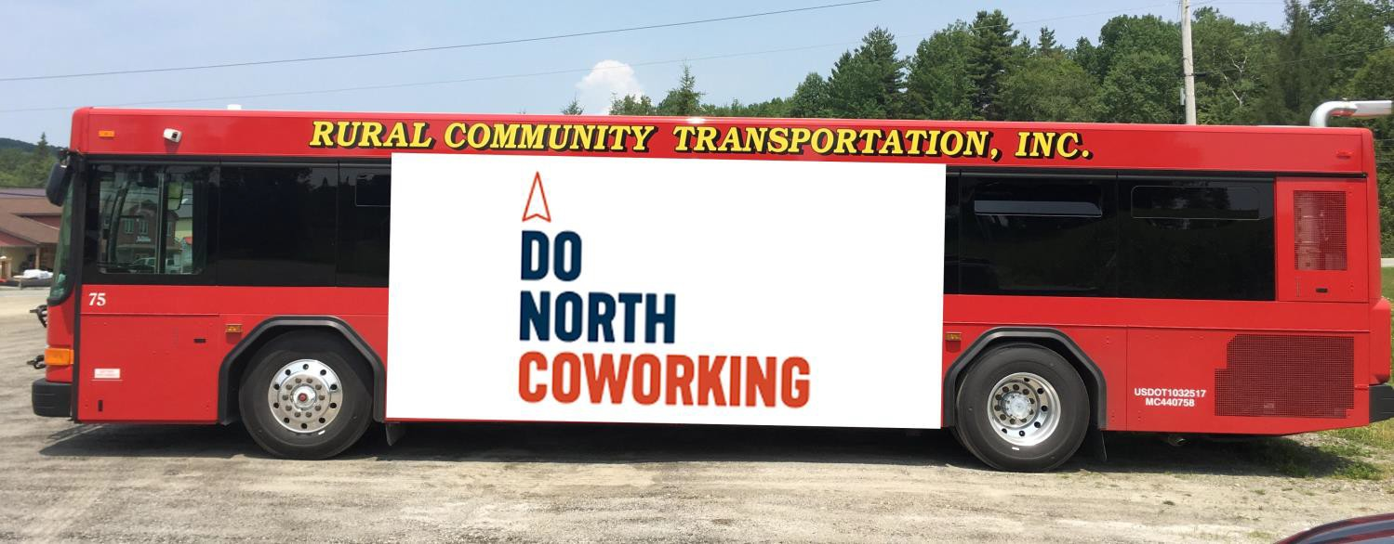
Call 802-624-3844 or lbennett@riderct.org for more information

Decal Printing & Installation Costs:

Smaller decals can be designed and printed to fit on the smaller buses and vans. They are digitally printed so can be full colors with no extra cost. The prices are as follows:

$6/ square foot for printing and install

$200 per month per sign for 21”X 30”

$400 per month per sign for 21” by 96”

$40 design fee with up to three revisions

Design costs are included in the printing and install

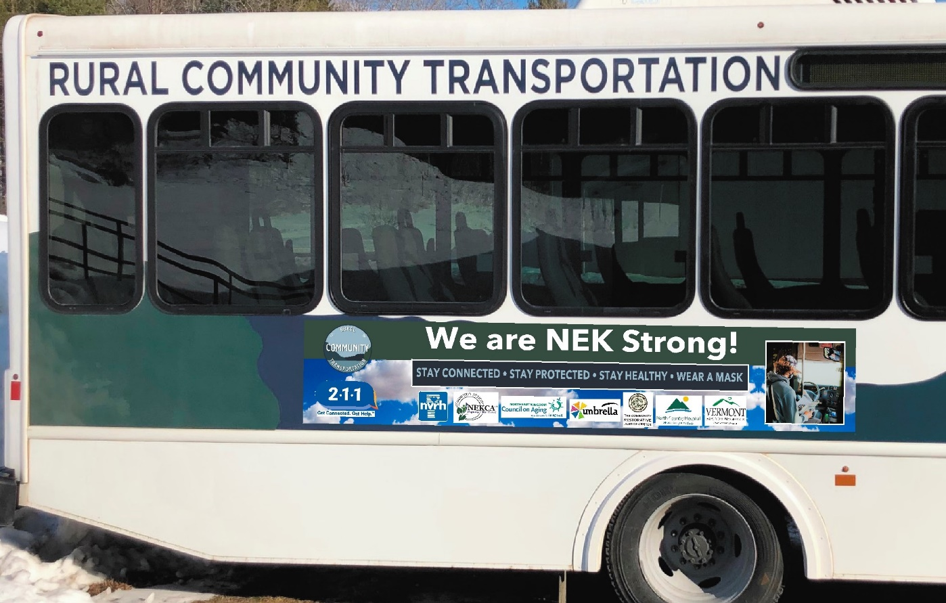

Interior Signage: 11.5” X 36”

$40 design fee with up to three revisions

$6/ square foot printing and installation

$50/ month per sign rental of the space

Smaller signage will run along the top of the walls in the bus much like signage on a subway.

We will offer volume discounts for multiple buses.

